Product Operation Manual

低温等离子表面活化机使用手册
PLASMA SURFACE TREATMENT SYSTEM

◆活 化 Activation
◆清 洗 Clean
◆刻 蚀 Etching
◆聚 合 Aggregation
◆接 枝 Graft

Plasma surface treatment machine

I. Brief introduction of atmospheric plasma surface treatment equipment

The atmospheric low-temperature plasma treatment machine consist of a plasma generator, a gas delivery system, a pressure protection system and a plasma nozzle
And so on. The high voltage and high frequency energy generated by the plasma generator is used in the glow discharge which is activated and controlled in the nozzle steel tube.
The air is ionized to generate a low-temperature plasma, and the plasma is sprayed to the surface of the workpiece by means of compressed air.
When the surfaces of the treated objects meet, a series of chemical reactions and physical changes occur, and the surfaces are cleaned and the hydrocarbons are removed.
The surface molecular chain structure of contaminants, such as grease, auxiliary additives, etc., is changed according to the material composition. Established a hydroxyl group
Radical, carbon radical and other free radicals, which have the function of promoting the adhesion of various coating materials, and are used in adhesion and paint applications.
Has been optimized. At that same effect, the application of a plasma treatment to the surface can result in a very thin, high-tension coat surface,
Any other strongly act components such as mechanical or chemical treatment are not require to increase that adhesion. By low temperature plasma surface treatment,
The surface of the material undergoes a variety of physical and chemical changes, or is etched and rough, or a dense crosslinked layer is formed, or a layer containing
Hydrophilicity, cohesiveness, dyeability, biocompatibility, and electrical properties are improved by the use of oxygen polar groups. In a suitable
The surface of the material is treated under the process conditions, so that the surface morphology of the material is remarkably changed, various oxygen-containing groups are introduced,
The surface is changed from non-polarity and difficult adhesion to certain polarity, easy adhesion and hydrophilicity, which is beneficial to bonding, coating and printing.
At present, corona treatment has been widely used in the production of various thin films to solve the problem of surface affinity. But because of many
The reason is that corona can only be carried out between two adjacent parallel electrodes, and the distance can not be too large, so the method of corona treatment is not suitable.
It can be used to deal with the surface polarization of three-dimensional objects. The weakness of the flame process is that all polymers are flammable
And a low Mel point. When the organic material is exposed to a high temperature flame, it will be deformed, discolored, rough in surface,
It burns and emits toxic gases, and the treatment process is difficult to master. The key is the high cost and danger.

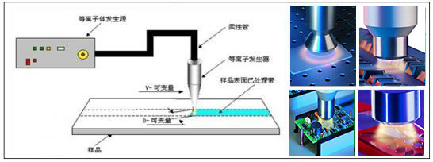
The low temperature plasma jet treatment process is the best scheme for the surface modification of three-dimensional objects. The principle is shown in Figure 1-1 above.
AC high frequency high voltage is applied to both ends of the electrodes to ionize the air between the two electrodes to generate gas arc discharge to form a plasma region.
The plasma reaches the treated surface under the blowing of the airflow to achieve the purpose of modifying the 3D surface.

● Features
★ The ejected plasma flow is neutral and uncharged, which can be applied to various polymers, metals, glass, rubber, PCB,
PP, silica gel, and other materials for surface treatment;
★ Improve the bonding strength, for example, PP material can be increased several times after treatment, and the surface energy of most parts can reach 60% after treatment.
Due to the above;
★ After plasma treatment, the surface performance is durable and stable, and the retention time is long;
★ The dry method has no pollution, no waste water, and meets the requirements of environmental protection;
★ It can be operated on the production line to reduce the cost.

II. Main technical indicators

 | ZP750 | XZ750
输入电源  Input power | AC220V 50HZ | AC220V 50HZ
喷枪直径  Diameter of spray gun | 8mm | 46mm
最大功率  Maximum power | 750W | 750W
喷头处理宽度  Processed width of nozzle | 8mm-12mm | 46mm-50mm
频 率  Frequency | 50Hz | 50Hz
输入气源压力  Input air pressure | ≥0.2Mpa | ≥0.3Mpa
输出工作压力  Output working pressure | ≥0.1Mpa | ≥0.15Mpa
高压线长度  Length of high voltage line | 2.M | 2M
主机重量  Weight of the host | 10.5KG | 11KG
主机外形尺寸  External dimension of the host | 435mm*220mm*300mm | 435mm*220mm*300mm
使用温度范围  Operating temperature range | -10℃~+50℃ | -10℃~+50℃

三、安装 Installation

1、设备结构 Device structure
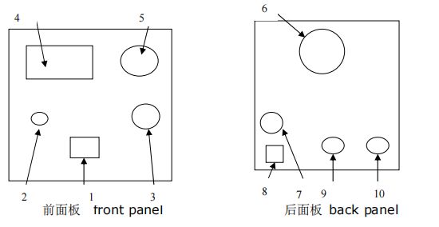

1.设备外观图 The outside view drawing of equipment
1、主机电源开关 Power switch
2、启动/停止开关 start stop switch
3、离子调节 Plasma regulate
4、面板显示 Panel display
5、气压表 Gas pressure meter
6、风扇 Cooling fan
7、外部气源输入 Input of external air supply pipeline
8、电源输入 Power input of the host
9、外部控制信号输入 Plasma remote control socket
10、枪头输出接口 Plasma spray gun output
11、枪头输出接口 Plasma spray gun output
12、气体输出接口 Gas ouput interface

2. Equipment installation
1) Installation of sprinkler
A. Install the nozzle on the appropriate fixed support or manipulator, and use appropriate fixing measures to fix the high-voltage cable and ground wire on the nozzle.
And the trachea is not subjected to strong pulling, friction and scratching by sharp objects.
B. Adjust the distance between the nozzle and the work to be processed between 8 and 12 mm. (The processing distance depends on the material, speed,
And the subsequent process to adjust the experiment, the closer the relative distance, the greater the processing strength, but too close distance will ablate the material)
2) Placement of host
A. When the equipment is working, the fan and exhaust window of the host shall not be blocked by objects.
B. The four sides of the host shall not be placed close to a large area of iron surface, and the four sides of the equipment shall be more than 10 cm away from this kind of material. Otherwise it will
Increased power consumption and increased temperature rise of the equipment due to eddy current losses.
C. Connection of air pipe: connect the compressed air pipe to the "air source input" interface 7, and the input pressure of the air source is greater than 4 bar.
3) Connection of AC220V power supply
A. Please select a wire with a specification greater than 0.75mm2 to reliably connect the power supply AC220V to the host power input interface 8.
The connection has no polarity, but it cannot be connected to the ground incorrectly.
B. The "ground" terminal must be connected to the "earth ground".
4) The air source output of the air compressor is required to be provided with an oil filter and a water filter, otherwise the treatment effect will be affected.
5) Connection of output plasma external control and manipulator control circuit: insert the external control plug of the accessory into the "external control" socket
9 Install and lock the nut. The two control lines are connected with the control circuit of the manipulator, the control mode is on-off control,
Spray, no plasma spray when off. The control elements of the robot can be controlled using elements such as relays or switches. (Note
External control shall not have voltage input, otherwise the host will be damaged!)

Use of equipment
1. Turn the power switch to the ON position (the OFF position means shutdown), the power supply of the main engine is supplied, and the barometer displays the air pressure: direct injection
Type air pressure is greater than 0.1MPa, rotary type is greater than 0.2MPa.
Start -- Press the start switch solenoid valve to connect the air, the nozzle blows out the air first, and then the plasma is sprayed out after 0.1-0.2 seconds.
Stop -- In the start state, press the start/stop switch again, and the equipment can be restored to the standby state.
Ion adjustment -- In the process of continuous spraying of ions, the adjustment knob can be adjusted to change the intensity of ions to adapt to the treatment effect of different materials.
Note: Make adjustment after the equipment is started. If the equipment is in the standby state, the knob should be set to the middle position to facilitate the starting of instantaneous arc discharge.
- When the output external control socket 9 is connected (the plug has been connected), the nozzle will spray plasma, otherwise, there will be no plasma spray.
- The moving speed of plasma spray gun shall be greater than 0.2m/s according to different materials.
- The main factors affecting the plasma treatment effect are material, running speed, treatment power, working air pressure and input compressed air.
- Precautions
1. Plasma equipment is special equipment. Personnel without professional knowledge are not allowed to open the chassis to maintain the equipment.
2. The ground wire terminal of the host must be reliably connected to the (earth) ground wire;
3. The high-voltage cable between the nozzle and the host shall be routed naturally and shall not be bent at a large angle;
4. Pay attention to protect the high-voltage cable to prevent the insulation layer of the high-voltage cable from being scratched by sharp instruments;
5. The human body shall not touch the inner flame of the ejected plasma.
6. The external control interface prohibits voltage input.
7. The air source required for the machine to work must be water-free and oil-free compressed air. Bad air source will cause damage to the plasma nozzle.
8. If there is no gas or the gas source flow is insufficient, the equipment will automatically shut down for protection.
9. For the low-temperature plasma flame from the nozzle, please use the orange area in the middle, which is 8mm ~ 12mm away from the nozzle.
10. It is strictly prohibited to use in flammable and explosive gas environment.
- Dyne pen test method
I. Performance Introduction
Dyne pen. It can accurately test whether the surface tension reaches the value of the test pen. Make it clear to the user whether the material is suitable for printing. Composite or vacuum aluminizing, etc. Effectively control quality and reduce tool delays due to nonconforming materials.
II. Test method
In industrial practice, the surface energy (surface tension) is determined by testing the ink according to DIN ISO 8296 by brushing an ink stick about 100 mm long on the film to be tested with inks of different known surface energies, and observing whether more than 90% of the ink stick edges shrink and form ink droplets within 2 seconds, if any. Then the ink with a lower level of surface energy is used to brush the ink bar again, and the same observation is carried out until the ink drops do not shrink and appear, and the surface energy of the test ink corresponds to the surface energy of the film. The method can accurately measure the surface tension and surface wet force of the substrate and determine whether the surface factors of the substrate before work meet the requirements so as to adjust the ink, coating and viscosity to meet the needs of work.
There were twenty-one test inks with surface energy levels from 30 to 72 mN/m (each differing by 2 mN/m). Dyne (38 mN/m) can be used as a quick test for surface energy after corona treatment, but is not suitable for systematic testing of printed or coated surfaces. When the test pen draws a line on the corona treated surface, if it is a continuous line, it indicates that the surface energy of the material is not less than 38 mN/m. If it is not a continuous line, it indicates that the surface energy of the material is less than 38 mN/m. The treatment is insufficient or even not treated, which does not meet the requirements of printing processing.
Surface tension and surface wetting power are very clear standards for accurately measuring the adhesion of printing ink and other materials on the surface, but there are other factors affecting viscosity, such as static electricity and many additives. However, these factors are not often shown in the test, even if the test results are very good but the reality is not satisfactory. It is necessary to discuss these technical issues with raw material suppliers. Generally speaking, the above situation will not happen to them, and the surface value of 38-41 mN/m can meet the viscosity requirements. When the surface tension is below 37 mN/m, many white pages (no printing content) are generated, and when the surface tension is below 35 mN/m, the viscosity is not good.
Standard Test Methods for Dyne Pen
Summary: The following problems should be paid attention to when using Dyne pen to test the surface tension of PP, PE, PET, PAPC, etc.
Dyne pen, also known as surface tension test pen, corona treatment pen, and plastic film surface tension test pen. It is a test tool for surface corona degree (dyne), which is specially used for the effect of corona treatment.
The surface tension test pen has more than ten different tension test pens of 32, 34, 36, 38, 40, 42, 44, 46, 48, 50, 52, 54, 56, 58, 60 or above, which can accurately test whether the surface tension reaches the value of the test pen. The user can clearly know whether the material is suitable for printing, laminating or vacuum aluminizing, etc., thereby effectively controlling the quality and reducing the loss caused by the unqualified material.
Test method:
1. In industrial practice, the surface energy (surface tension) is determined by testing the ink according to DIN ISO 8296, which is to brush an ink stick about 100 mm long on the film to be tested with inks of different known surface energies, and observe whether more than 90% of the ink stick edges shrink and form ink droplets within 2 seconds.
2. During the test, an intermediate value shall be selected as the starting point, such as 38mN/m. During the test, if the test pen wets the surface of the substrate within 2 seconds, the surface tension of the substrate is larger or just right than the selected value, then it is necessary to select a test pen with a larger value for the second test, and so on, until the test result shrinks into water droplets (spherical) within 2 seconds. The previous value for this test is taken as the surface energy of the substrate. And use it for comparison and analysis.
3. In general, 6 different types of surface tension test pens are required for the first test to ensure the accuracy of measurement; if it is determined that the number of film surface tension changes very little, at least 3 different types of surface tension test pens are required.
4. Surface tension and surface wet force are very clear standards for accurately measuring the adhesion of printing ink and other materials on the surface, but there are other factors affecting viscosity, such as static electricity and many additives. However, these factors are not often shown in the test, even if the test results are very good but the reality is not satisfactory. It is necessary to discuss these technical issues with raw material suppliers.
- Appendix
- Mixture formula commonly used in production to measure wetting tension and surface temperature and wetting tension that can be measured:
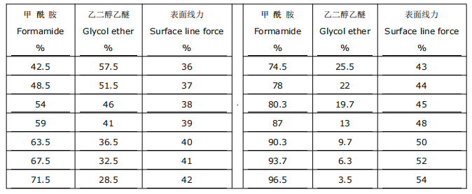

- Requirements for plasma surface treatment of general materials
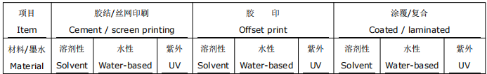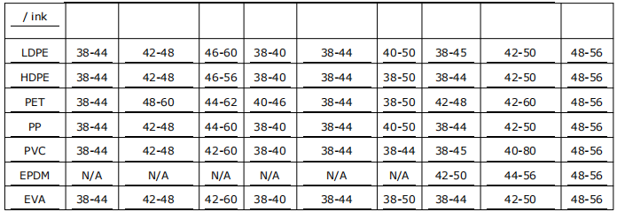

Fault inspection and troubleshooting
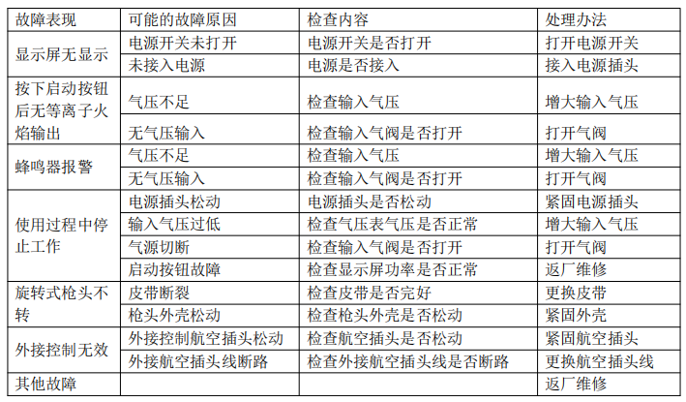

Product warranty card
Purchased by:
Product name and specification:
Quantity
Date of shipment:
Product No.:

The company's products are strictly tested factory, performance assurance, excellent quality. In order to ensure the rights and interests of customers, this product is
Under regular use, if it is the quality factor of the product itself, our company will guarantee it for 12 months free of charge (from the date of purchase).
Defects caused by the following factors are not covered by the warranty. However, our company can still serve you at the cost of parts.
1. Problems caused by incorrect operation or unauthorized modification and repair.
2. Aging or failure when used beyond the standard technical requirements or environmental requirements.
3. Careless transportation and installation after purchase (such as falling, collision, extrusion, excessive force) damage.
4. Corrosive material damage.
5. Faults caused by natural disasters or man-made disasters and other accompanying reasons.
6. Other damages or failures caused by factors other than the quality of the product itself.

